Homework Project
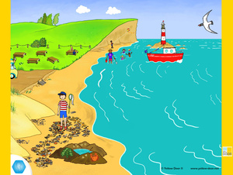
It is time to get creative again! This half term for homework I would like you to do a project on The Seaside. You can choose from one of these ideas or do one of your own.
- Collect things from the beach and make a seaside collage
- Find out about the seaside in the past.
- Make a map of all the seaside towns in Great Britain. What is each one famous for?
- Make a tourist information leaflet about a seaside town.
- Design a new seaside town. What things would you like to have there?
- Find out about all the different things there are to do in Blackpool.
Please bring your projects in by Friday 12th July.

You can decide how to present your work. e.g.
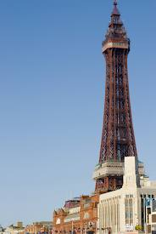
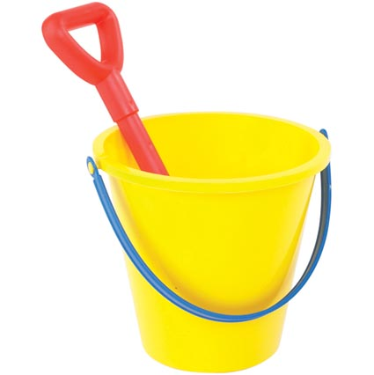
- A poster
- Make a model
- Information booklet
- Painting or drawing
- Write a story
- Or an idea of your own
- Be as creative as you like!

