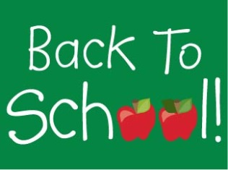
Dear Parents/Guardians,
Welcome to Year 1!
I hope you have had a lovely summer together and are looking forward to the new school year.
This year, your child will need a book bag (these will be kept in your child’s tray)and a named draw string bag to put their PE kit in (no rucksacks please as we keep all PE kits in the in boxes in the classroom and have very little room!)
Please ensure everything is clearly named and labelled, including all items of clothing.
We will begin our year of learning with our first topic - ‘Superheros’. A topic web and word mat available on a class page . Shortly, I will send a letter inviting you in to school for a short workshop that will explain the year 1 curriculum, our approach to reading and phonics and your child’s homework. Please try to attend as there will be a lot of important information that will help you and your child make the most of this academic year.
In Class 1 there will be 3 adults most of the time, this will be myself, Mrs Zinna, class teacher, Mrs Campbell, our class teaching assistant and alternatively Mrs Bryce, Mrs Dixson and Mrs Randall, who will help with all areas of learning. We are lucky enough to have our own outdoor area and lots of continuous provision so your child’s transition from reception should be happy and seamless.
Should you have any questions please don’t hesitate to speak to me at the end of the day.
Mrs Zinna
Year 1 class teacher, EYFS and KS 1 Key stage leader

