Europe

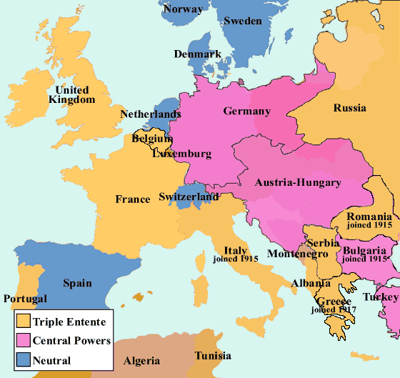

WW1 Word Mat

Why do we remember World War I?

**Europe**

Central Powers Triple Entente

Austria Great Britain

Hungary Russia

Germany France

Other Significant Countries

Serbia, Belgium, USA

England

Northumbria

Wessex

Mercia

Kent

East Anglia

assassinate

declare

treaty

allies

neutral

recruitment

No Man’s Land

Western Front

Battlefield

frontline

trench

soldier

bayonet

artillery

***1914 – 1918***

***The Great War***

Remembrance

11th November

The 11th hour of the 11th day of the 11th month.

Poppy

Cenotaph

Cemetery

Flanders Fields

Battles

Mons

Ypres

Jutland

Somme