**Art**

Andy Goldsworthy – Environmental Art

Exploring the theme of art in the natural world

Artist: Richard Shlling. Sculptures from natural materials

**English:**

Text: Kensuke’s Kingdom

Informal letter-Kensuke’s Kingdom

Balanced Argument - Debate

Text: Biography- Beatrix Potter

Narrative Story Opening

Leaflets - advertising the Lake District

**Science:**

Evolution and Inheritance.

Scientist: Charles Darwin.

**French**

Developing vocabulary and conversation

**Computing**

Creating a website about our time at St John’s School

**P.E**

Net and Ball Games

(Badminton and Tennis)

Sports Day – developing leadership skills

**Geography**

The features of the Lake District and how humans use the natural resources

Researching the lakes and mountains of the region

Recognising the impact of people on the natural environment

Comparing the Lake District to Blackpool

Monday 15th July – class visit to

The Lake District

**R.E**

Ideas about God

People of Faith

**Maths**

Algebra

Measurement

4 Operations

Geometry

Place Value

Fractions and Decimals

**Class 6-Summer Term 2 2018**

**THE LAKE DISTRICT**

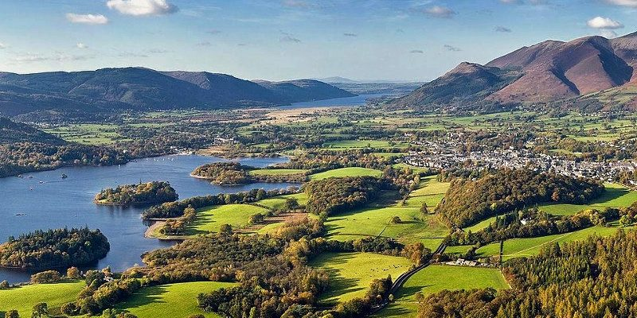

**PSHE**

Changing Me

Changes as we grow up

Transition to High School