**Visits**

Lancashire Infantry Museum

Blackpool Cenotaph

**English**

“The Trenches”

By Jim Eldridge

**Reading**

Developing comprehension skills and inference.

**Writing**

Descriptive language to describe the characters and setting.

Use of dialogue to develop the story.

**World War I Poetry**

“For the Fallen”

“In Flanders Fields”

**Placing Events in History**

Using a timeline to understand when World War I took place and the significant events between 1914 and 1918.

**History**

**World War I**

* Understanding the reasons for the outbreak of war
* Describing life in the trenches
* Researching the major battles of the war
* Understanding the role of significant people in war
* Describing the Christmas Truces
* Understanding the importance of remembrance

Why do we still remember World War I?

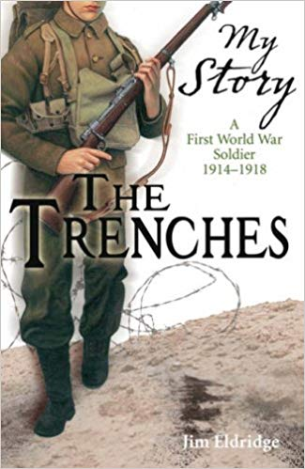

**Class 5 - Autumn 2**

**World War 1**