Knowledge Organiser Year 5 – Rivers
Mouth | The end of the river. The mouth may be where the river meets the sea, a lake or a larger waterway. Most rivers flow out into the sea and this is where they end their journey. | 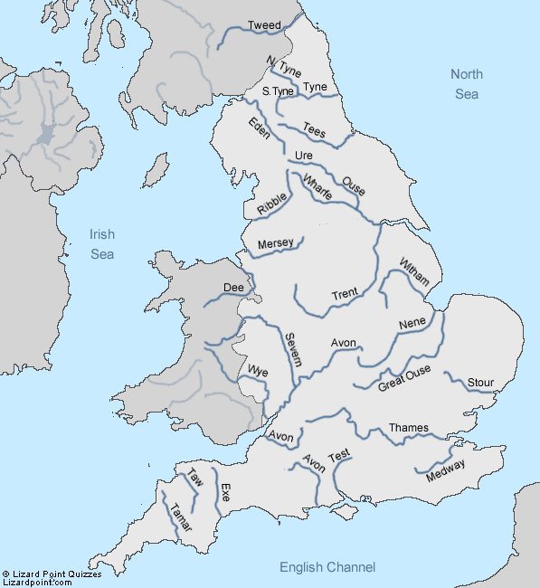  The Severn River is the longest river that flows through England and measures 354 kilometres or 220 miles in length. It begins in Wales and passes through the West Midlands and South West England where it enters the Atlantic Ocean near Bristol.  The Thames flows into the North Sea. It flows through Oxford and London and measures 346KM. It is the deepest river in Britain.  The Mersey River is important due to its having a port in the city of Liverpool. It is approximately 112 km long and passes through the counties of Merseyside and Cheshire. This river is made up of three major tributaries; namely the rivers Goyt, Etherow and Tame. Officially and according to modern definitions, the Mersey begins where the Tame River and the Goyt River converge. | 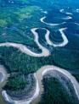  The Amazon river is the second longest river in the worls and measures 6400km. It runs from the Andes Mountains in Peru through Bolivia, Venezuela, Ecuador and Brazil where it joins the Atlantic Ocean.  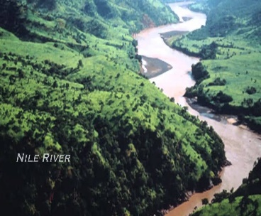  The Nile River is the longest river in the world and measures about 6695Km. It originates from Burundi in Central Africa and flows northwards through Ethiopia, Sudan and finally  Egypt where it drains into the  Mediterranean.  The Rhine is one of Europe’s longest rivers measuring 1232km. Its source is in the Swiss Alps in Switzerland and it flows through 6 countries in total before flowing into the North Sea at Rotterdam in the Netherlands,
Source | Where the stream begins: usually where there is a spring and quite high up.
Sediment | The name given to material that has been carried by rivers or the sea and then deposited. Sediment may be called alluvium if it is deposited on the bed of a river. It may be called a beach when deposited by waves.
Confluence | Where two rivers or streams meet
Current | The flow of the river
Erosion | The wearing away, in this case by water and rocks constantly rubbing.
Gorge | A gorge is a steep sided valley which is very narrow and deep. Most gorges have rocky sides. The river cuts this deep valley by erosion. Gorges are created over thousands of years.
Meander | A bend in a river- usually in the middle or lower course. The meander continually changes shape as the fast-flowing current of water erodes the outside bank of the meander bend and deposition occurs in the slack water of the inside of the bend. |  | 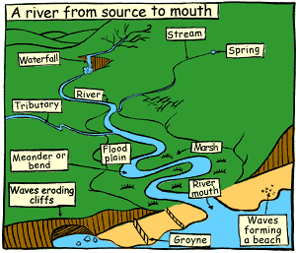
Rapids | Rapids are fast flowing stretches of water formed where the river surface breaks up into waves because rocks are near to the surface.
Waterfall | A place where the river course is interrupted by a tall step.

