WASTE MATTERS – Knowledge Organiser Year 4 Spring 2
VOCABULARY |  | THE 7 CONTINENTS AND 5 OCEANS | WHY DO OCEANS MATTER?
Plastic | A type of material that is made by people and can be formed into any shape. | 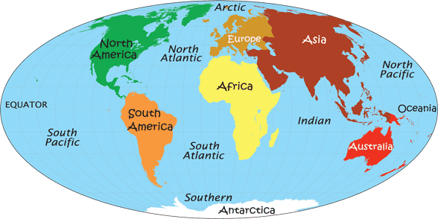 | - Over 700 million people depend on fishing.  - Fish and seafood are the main source of protein for more than a billion of us.  - They are home to an incredible variety of wildlife.  - Home to the largest animal ever to live on Earth, the blue whale.  - Around 70% of the world’s people live within 60km of the sea.  - Around 80% of all tourism takes place in coastal areas.
Pollution | When the environment is contaminated or dirtied by waste, chemicals and other harmful substances.
Landfill | Huge holes in the ground that we fill with rubbish and cover with soil.
Gyres | Rotating ocean currents.
Biodegradable | Is able to break down into very small harmless parts by the action of living things e.g. bacteria. | KEY PLACES
Henderson Island
- A British Island in the South Pacific Ocean halfway between New Zealand and Chile.
- Nobody lives there but it is the most polluted place on the planet with 38 million pieces of plastic on its beaches.
- 3,500 pieces of plastic are deposited there every day.
- Plastic has been found from: Russia, the US, Europe, South America, Japan and China.
South Pacific Garbage Patch
- Plastic gets caught up in the ocean currents (gyres) and collects in huge areas.
- The garbage patch is larger than the country of India.
- Most of the plastic found is microplastic.
- Eventually the plastic will sink and be carried around the planet by ocean currents.
 |  |  | REMEMBER THE FIVE Rs
Bioplastic | Biodegradable plastic that is made from biological materials. |  | - Rethink – what things do you really need?  - Refuse plastic where you can – it can help make a point.  - Reduce the amount of plastic you use.  - Reuse items where you can.  - Recycle as much as possible
Microbead | Tiny pieces of plastic that are less than 1mm in size. They can be found in some cosmetics and toothpastes.
Microplastics | Tiny pieces of plastic less than 5mm across. A major cause of ocean pollution.
Single use plastic | Plastic products that are only used once before they are thrown away.

