Our Local Area
We live in a town
We live by the sea
Do you know your address?
Key Vocabulary
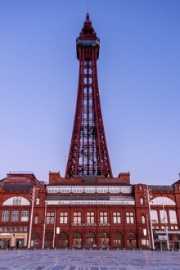  The Tower | A tall tower and a place for people to visit  Have you been inside?  What did you see? | 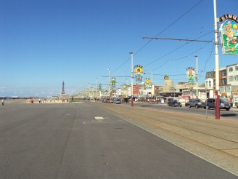  The Promenade | A path to walk on next to the sea.  What is the promenade?  What did you see and hear on the promenade?
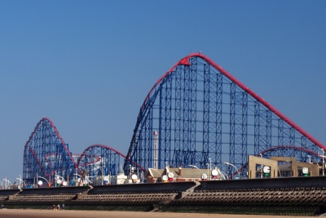  The Pleasure Beach | A fair with lots of rides.  Have you been on a ride? | 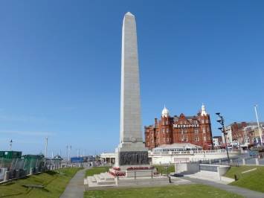  The Cenotaph | A monument remembering the people who died in the war.
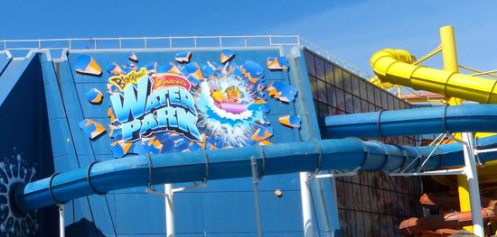  The Sandcastle | A swimming pool with lots of long slides.  Have you been swimming? | 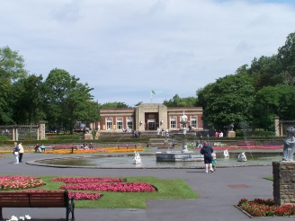  Stanley Park | A big garden for everyone to play and walk round.  Have you been to the park and did you visit the café or walk around the lake?
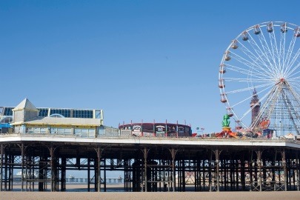  The 3 Piers | A platform that goes out into the sea which you can walk along.  Have you been on the pier and what did you do? | 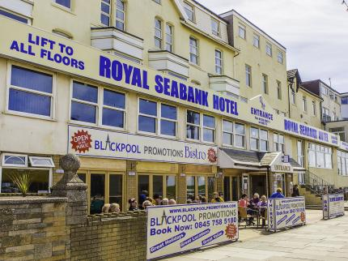  Hotels | A place to stay when on your holiday.  What is a hotel? Have you ever stayed in a hotel?

