Where are the places people call home? – Knowledge Organiser Year 4 Summer 2
KEY VOCABULARY |  | The five main countries refugees flee from
settlement | A place where people establish a community. | 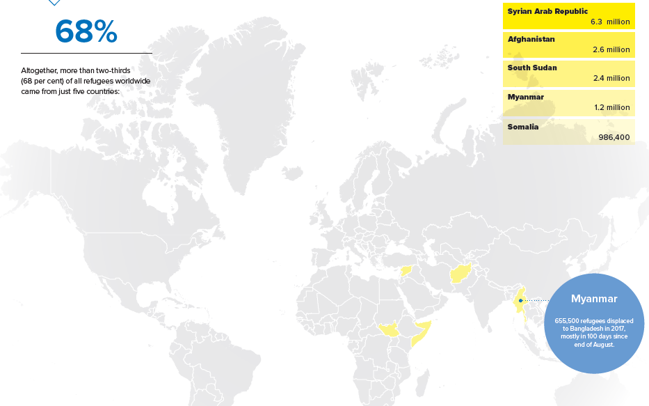
community | A group of people living in the same place.
rural | Relating to the countryside.
urban | Relating to a town or city.
hamlet | A settlement smaller than a village and without a church.
village | A group of houses and buildings larger than a hamlet but smaller than a town. Located in a rural area.
town | A built-up area with a local government, that is larger than a village and generally smaller than a city. | FUNCTIONS OF SETTLEMENTS | 5 GREAT MIGRATIONS
 |  | 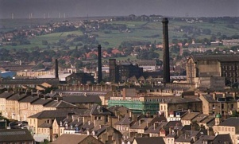  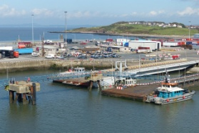  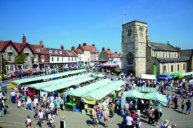  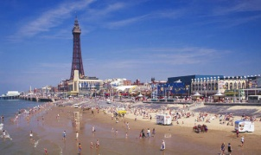  Resort  Industrial Town  Port  Market Town | Oregon Trail – 2000 miles, east to west trail travelled by settlers, farmers, fur traders and miners to fertile agricultural land.  The Great Trek – 1830s and 1840s. Dutch colonists migrated north from South Africa to find freedom in the interior of Africa.  Atlantic Slave Trade – 17th to 19th Century. 12 million Africans were captured and forced to work as slaves in the USA.  The Windrush – After WW2 people from the West Indies were encouraged to come to Britain to help solve the labour shortage. The Windrush was a boat that brought 492 migrants in 1948.  Emigration to Australia – between 1945 and 2007 around 2 million Britain’s settled in Australia to help boost the Australian population.
city | A large town, usually containing a cathedral.
population | All the people who live in a particular place.
migration | Movement of people to a new area or country.
refugee | A person who has been forced to leave their country to escape war, persecution or a natural disaster.

