**Art**

*Drawing portraits.

*People In Action.

*Study the Artist/Photographer Eadweard Muybridge.

*Art, craft and design work showing movement to the theme of sport/dance/music.

*Use photographs/magazine cuttings of people in action.

**English**

* Poetry-The Power Of Imagery
* Wim Hof The Ice Man-(Non-Chronological Reports) Captain Scott – Race to the Pole

(Mr Corser’s English Group)

* Discussion Texts: Should Under 16 year olds be banned from eating junk food? Miss Johnston’s English Group
* Text: ‘Pig Heart Boy’ by Malorie Blackman. Miss Johnston’s English Group

**Science**

*Identify and name the main parts of the human circulatory system.

*Describe the functions of the heart, blood vessels and blood.

* Recognise the impact of diet, exercise, drugs and lifestyle on the way their bodies function.

*Describe the ways in which nutrients and water are transported within animals, including humans.

**PSHCE**

Health effects on the human body:

*Smoking/Alcohol/Drugs

*Presentation about particular drugs.

*Importance of exercise for good health.

**R.E**

Jewish Festival: Passover

The Importance of Passover to the Jewish faith

Why Christians celebrate the Eucharist

**Human Body**

**Class 6 Spring 1**

**2018**

**Visit: Eureka Museum**

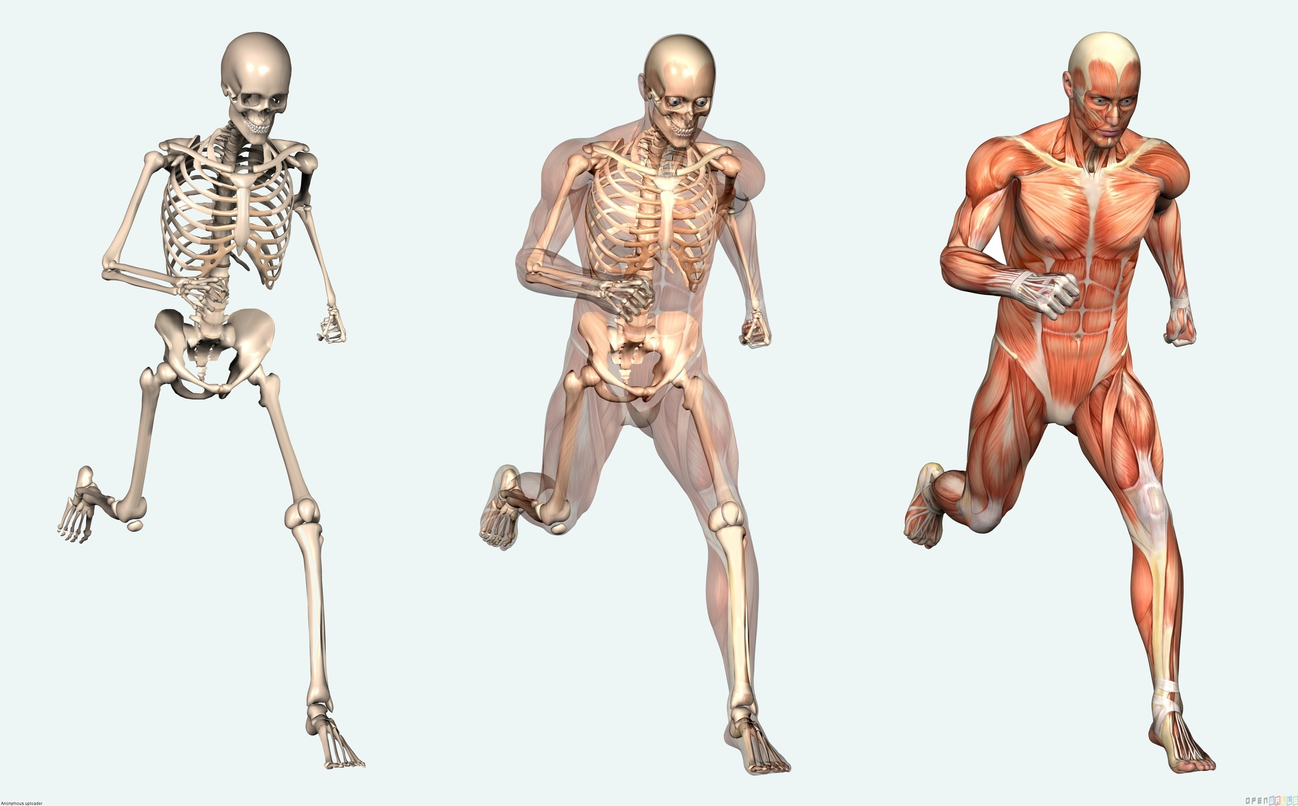

**Maths**

Place value and Sequences

Shape

Measures

Calculating with Fractions

Solving problems using all four operations

**Computing**

Learning how to use a school email account safely. Using Google classroom to enhance learning.

**Music**

Songs for “School’s Alive”

**P.E**

Dance-“School’s Alive” Performance.