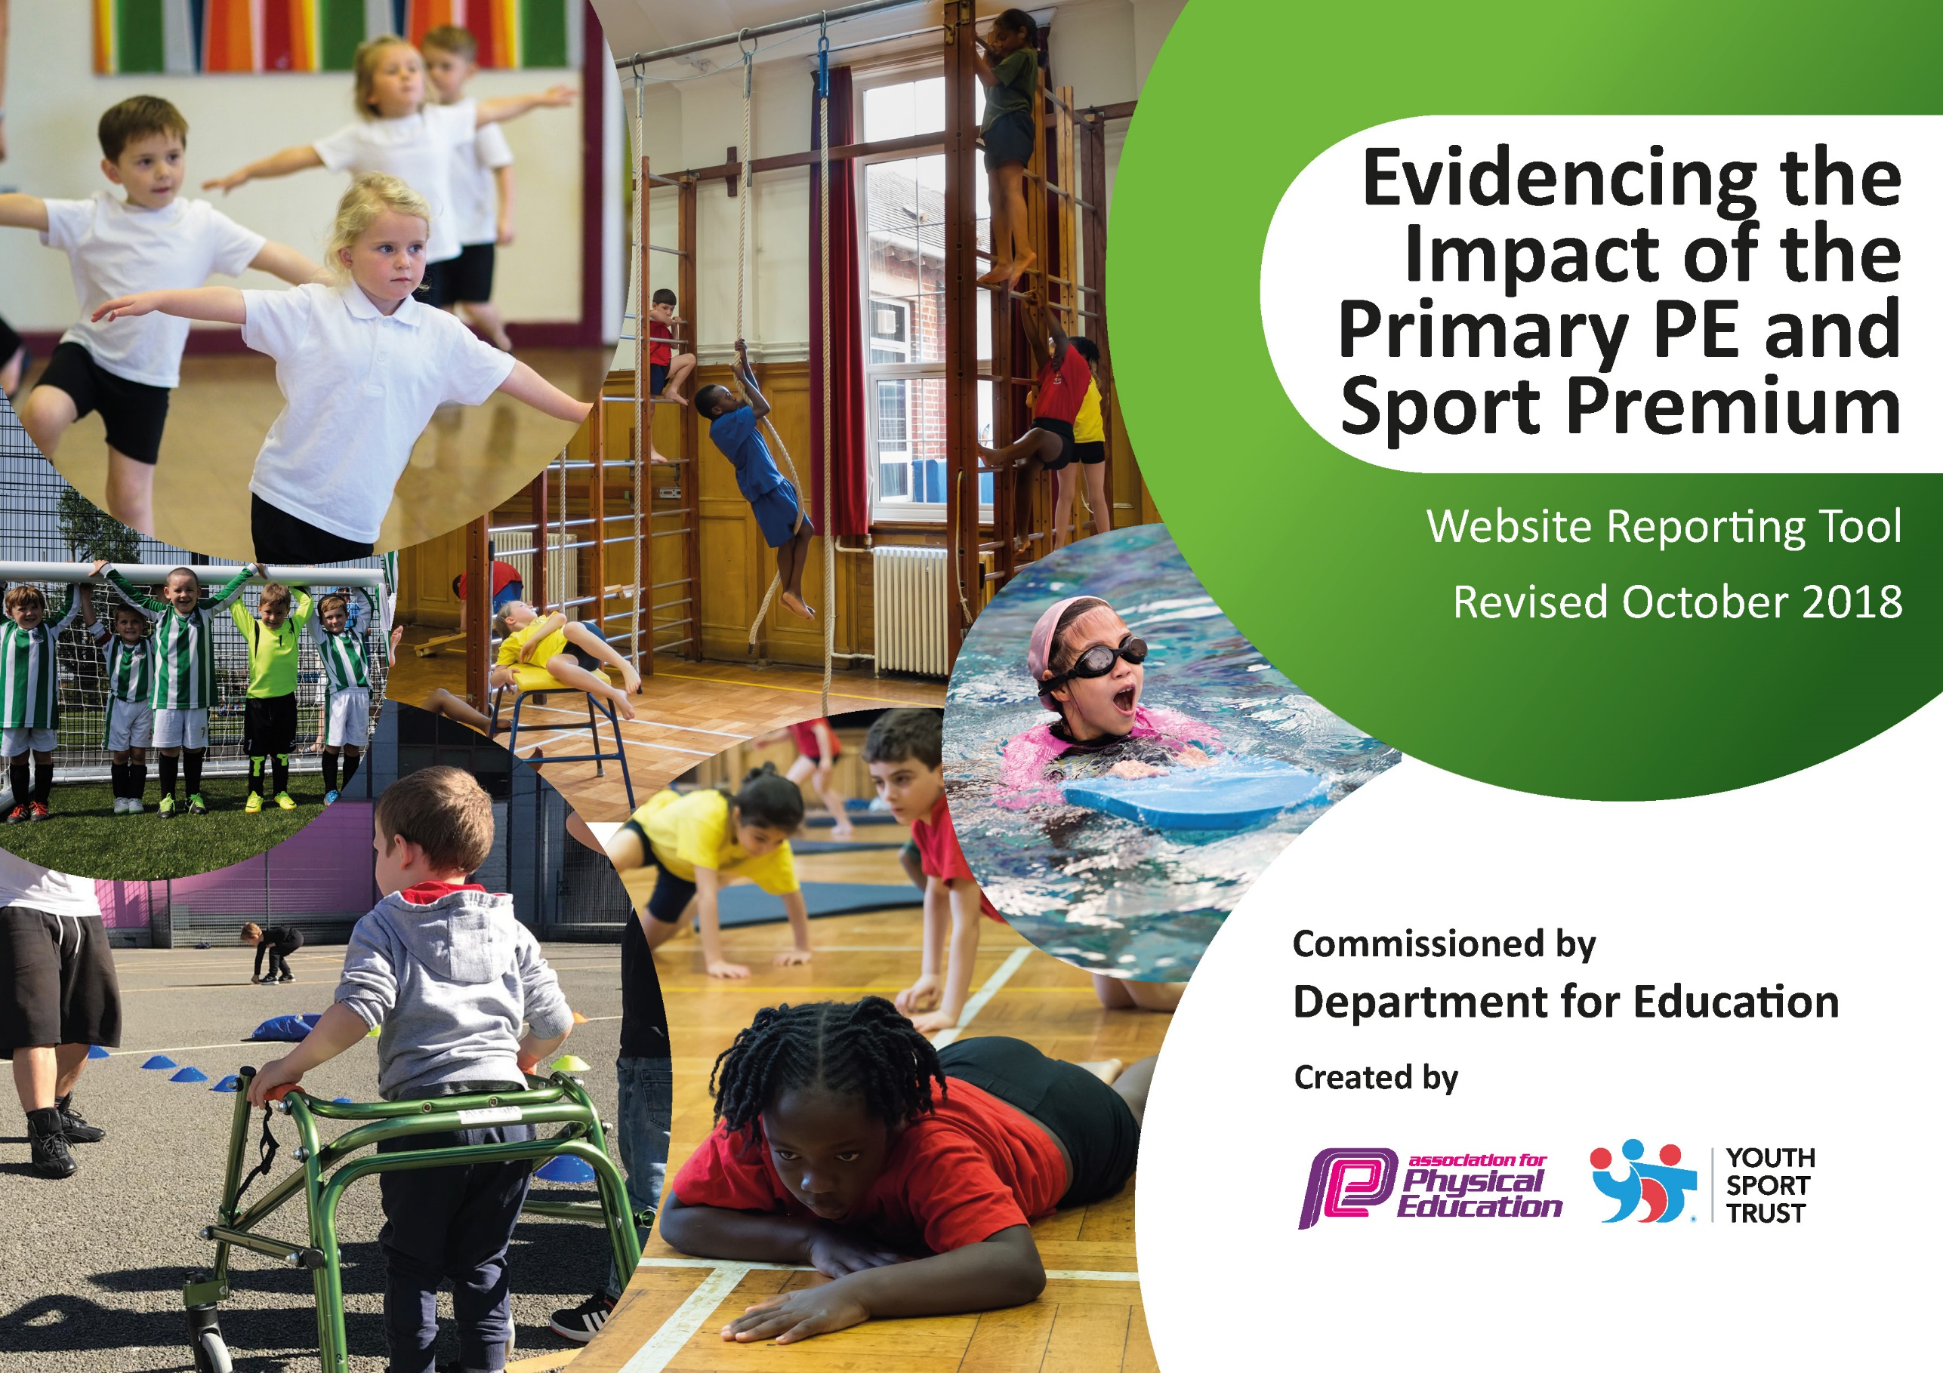
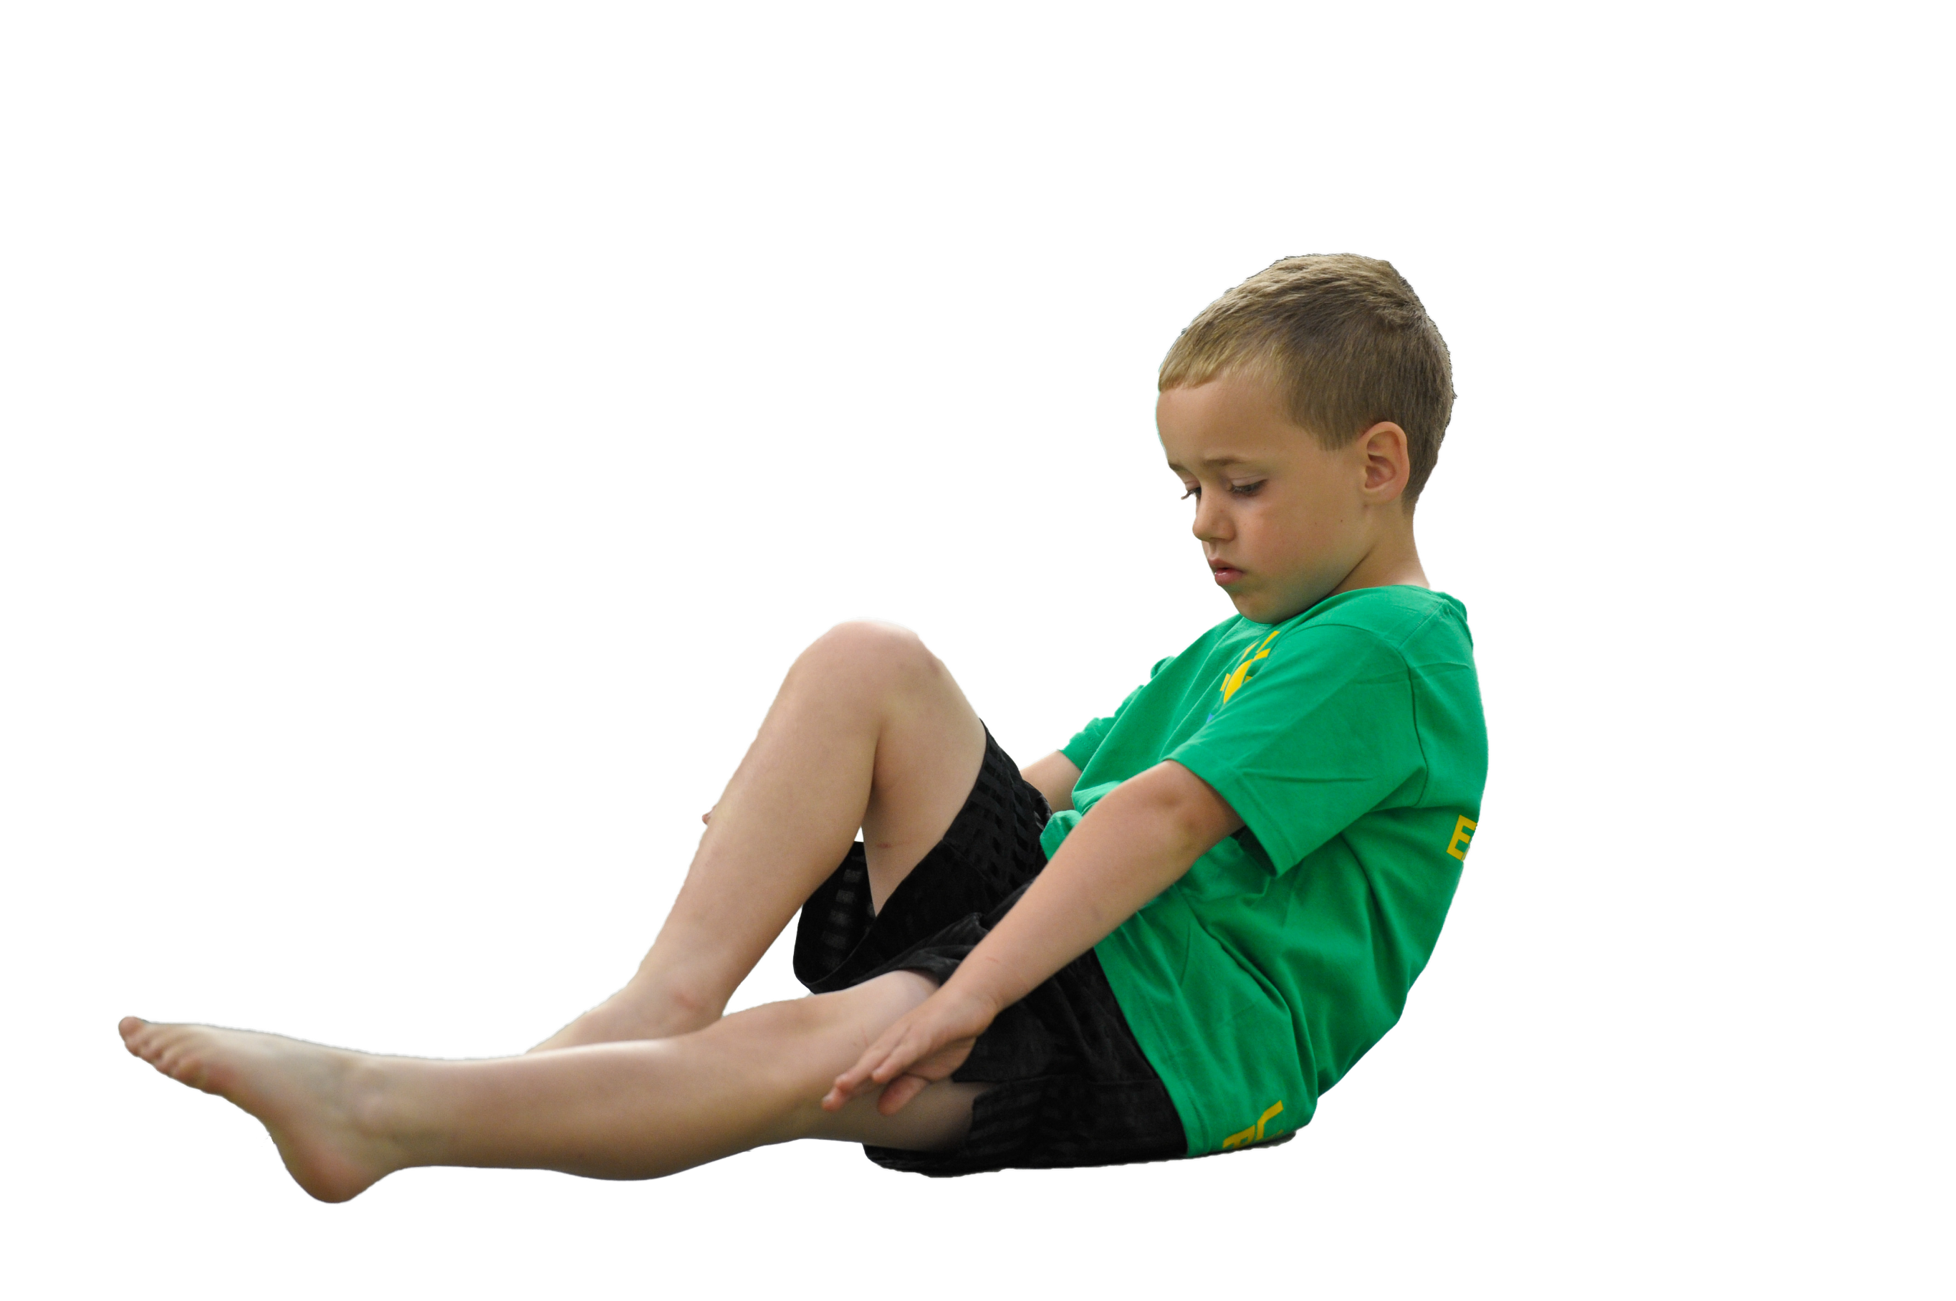
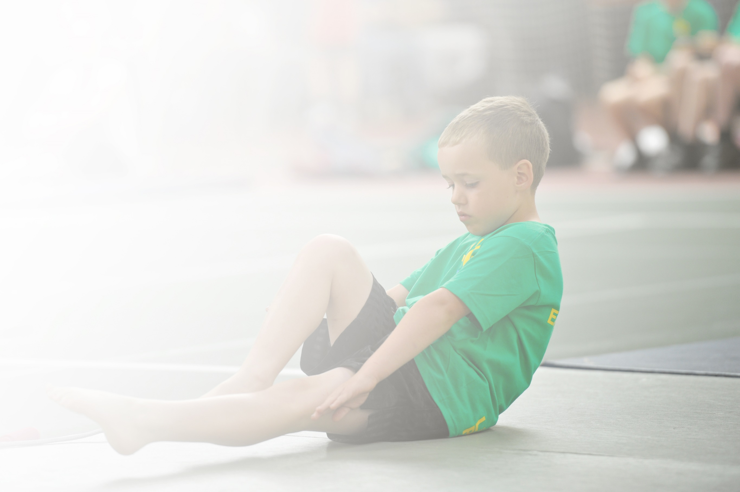
Schools must use the funding to make additional and sustainable improvements to the quality of Physical Education, Sport and Physical Activity (PESPA) they offer. This means that you should use the Primary PE and Sport Premium to:

- Develop or add to the PESPA activities that your school already offer
- Build capacity and capability within the school to ensure that improvements made now will benefit pupils joining the school in future years

Please visit gov.uk for the revised DfE guidance including the 5 key indicators across which schools should demonstrate an improvement. This document will help you to review your provision and to report
your spend. DfE encourages schools to use this template as an effective way of meeting the reporting requirements of the Primary PE and Sport Premium.

We recommend you start by reflecting on the impact of current provision and reviewing the previous
spend. Under the Ofsted Schools Inspection Framework, inspectors will assess how effectively leaders use the Primary PE and Sport Premium and measure its impact on outcomes for pupils, and how effectively governors hold them to account for this.

Schools are required to publish details of how they spend this funding as well as on the impact it has on pupils’ PE and sport participation and attainment by the end of the summer term or by 31 July 2019 at the
latest.
We recommend regularly updating the table and publishing it
on your website throughout the year, as evidence of your
ongoing review into how you are using the money to
secure maximum, sustainable impact. To see an
example of how to complete the table please
click HERE.

Support for review and reflection - considering the 5 key indicators from DfE, what development needs are a priority for your setting and your students now and why? Use the space below to reflect on previous spend, identify current need and priorities for the future.

Key achievements to date: | Areas for further improvement and baseline evidence of need:
Further increased levels of participation in PE and Sport, including the Golden Mile  Offered a wider range of curricular and extra-curricular activities  Developed active lunchtimes  Participated in a broad range of competitions and festivals | The Golden Mile to be further developed within school  Further develop the link between physical activity and a balanced diet as part of a healthy lifestyle  Ascertain training needs for all adults across school who are involved in PE and Sport; signpost training opportunities

Meeting national curriculum requirements for swimming and water safety | Please complete all of the below:
What percentage of your current Year 6 cohort swim competently, confidently and proficiently over a distance of at least 25 metres?  N.B. Even though your children may swim in another year please report on their attainment on leaving  primary school. | 86%
What percentage of your current Year 6 cohort use a range of strokes effectively [for example, front crawl, backstroke and breaststroke]? | 86%
What percentage of your current Year 6 cohort perform safe self-rescue in different water-based situations? | 97%
Schools can choose to use the Primary PE and Sport Premium to provide additional provision for swimming but this must be for activity over and above the national curriculum requirements. Have you used it in this way? | Yes

Action Plan and Budget Tracking
Capture your intended annual spend against the 5 key indicators. Clarify the success criteria and evidence of impact that you intend to measure to evaluate for students today and for the future.

Academic Year: 2018/19 | Total fund allocated: £14000 | Date Updated: June 2019
Key indicator 1: The engagement of all pupils in regular physical activity – Chief Medical Officer guidelines recommend that primary school children undertake at least 30 minutes of physical activity a day in school |  |  |  | Percentage of total allocation:
 |  |  |  | 18.9%
School focus with clarity on intended impact on pupils: | Actions to achieve: | Funding allocated: | Evidence and impact: | Sustainability and suggested next steps:
Introduction of the Golden Mile, children run on a regular basis to increase their physical activity.  All classes to be offered extra-curricular opportunities  Develop active lunchtimes. | Premier Sport to train staff and 2 children from each class to be responsible for entering data.  Each class to run on a regular basis.  Breakfast and after school clubs offered, use of specialist coaches and school staff (Premier Sport, Blackpool Council Sport Team, BFC Community) | Premier  £2405  PES (Alan)  £238 | Data logged on Golden Mile site for individual children, classes and the school.  Registers kept to monitor attendance and level of participation. | Following the first year of the Golden Mile the concept needs to be further embedded.  Continue to expand the range of activities on offer to children.
Key indicator 2: The profile of PESSPA being raised across the school as a tool for whole school improvement |  |  |  | Percentage of total allocation:
 |  |  |  | 26.4%
School focus with clarity on intended impact on pupils: | Actions to achieve: | Funding allocated: | Evidence and impact: | Sustainability and suggested next steps:
Focus on active lunchtimes, giving the children a range of activities and to structure lunchtimes.  Sports Star of the Term awarded in each class, use of the website and display to raise the profile of successes and achievements. | Three new play leaders employed to work with children at lunchtime.  PALs trained.  New resources purchased. | Blackpool Council Sports £1950  Medals  £100  Resources  £1650 | Children engaged in a range of activities. Lunchtimes are more structured resulting in fewer issues, therefore after lunch the children are coming back into school more focused. | Develop a group (play leaders, PE lead and welfare staff) and meet termly to further improve lunchtimes.  Provide training opportunities for all lunchtime staff.

Key indicator 3: Increased confidence, knowledge and skills of all staff in teaching PE and sport |  |  |  | Percentage of total allocation:
 |  |  |  | 23%
School focus with clarity on intended  impact on pupils: | Actions to achieve: | Funding  allocated: | Evidence and impact: | Sustainability and suggested  next steps:
Use of specialist coaches to work alongside school staff to develop knowledge and confidence.  PE lead to work alongside staff to identify and meet the needs of staff. | External coaches to provide session plans and to share with school staff. Team planning and team teaching to aid development.  Provide new resources.  Staff meeting time, PE lead to work 1 to 1 with staff. | Premier  £2405  PES (Alan)  £476  Resources  £325 | Monitoring of PE across the school, discussions with staff and children. | Extend training to all staff working in the school who are involved with PE/Sport/Physical Activity.
Key indicator 4: Broader experience of a range of sports and activities offered to all pupils |  |  |  | Percentage of total allocation:
 |  |  |  | 28.4%
School focus with clarity on intended  impact on pupils: | Actions to achieve: | Funding  allocated: | Evidence and impact: | Sustainability and suggested  next steps:
Additional achievements:  School has entered various festivals and events to experience a wide range of activities.  External coaches provide additional opportunities. | Workshops ran by external organisations, use of Blackpool Council Sports Team to enable us to access different activities.  Focus on swimming to maximise swimming lessons, additional instructors. | Blackpool Council Sports £1950  Dance £275  Swimming Instructors  £1750 | The children have experienced additional sports e.g. angling, glow in the dark football, ballroom dancing. Attendance at breakfast and after school clubs allows children to access different sports. | Continue to build on the breadth of activities the children have been able to experience.
Key indicator 5: Increased participation in competitive sport |  |  |  | Percentage of total allocation:
 |  |  |  | 0%
School focus with clarity on intended  impact on pupils: | Actions to achieve: | Funding  allocated: | Evidence and impact: | Sustainability and suggested  next steps:
Children offered the opportunity to experience Level 1 competitions in a range of sports within school setting.  Level 2 competitions – experienced during the year and at Youth Games.  Level 3 – children represented Blackpool at the Lancashire Games. | Identify opportunities for competition within school, use of the house system to provide teams.  Enter inter-school events, within local competitions and county wide. Enter a range of sports to increase participation. | School Staff | Children are involved in competitive sport as a matter of course.  Children are offered opportunities to experience competitions with other schools on a regular basis. Level 3 competition experience to be the pinnacle for the school. | Work with school staff to further develop Level 1 opportunities e.g. at the end of units of work.  Extend the house system to KS1.

