Knowledge Organiser - Rainforests

Key question:
What and who live in the Amazon Rainforest?
Key information:
Where is the Amazon Rainforest? | The Amazon Rainforest is located in 9 different countries but the majority of it (around 60%) is located in Brazil. The rest of it can be found in Peru, Colombia, Ecuador, Bolivia, Venezuela, Guyana, Suriname and French Guiana. | 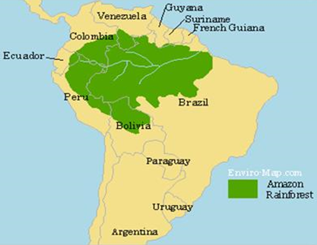
Key vocabulary: |  | The layers of the Rainforest:
Brazil - The largest country in South America. This is home to more than half of the Amazon Rainforest. |  | 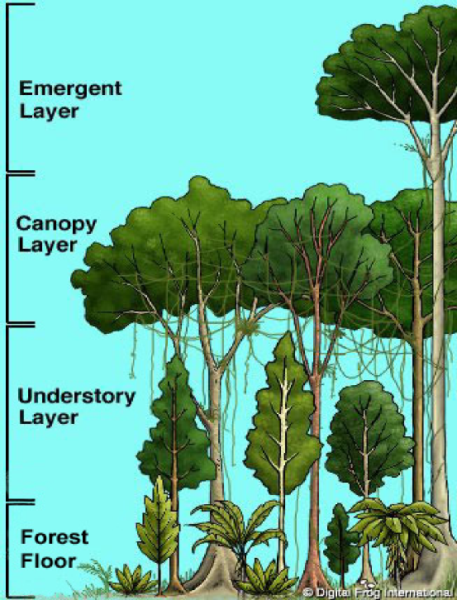
Amazon Rainforest - The largest Rainforest on Earth. It covers nearly half of South America!
Equator - An imaginary line that is drawn around the middle of the earth.
Tropics - Areas of the Earth that are near the equator. There are two tropics: The Tropic of Cancer and the Tropic of Capricorn.
Forest Floor - The bottom layer of a rainforest. This is where many of the larger rainforest animals live.
Understory Layer - The layer above the forest floor. Snakes, jaguars, lizards and lots of other animals live in this layer.
Canopy Layer - The layer of a tropical rainforest where plants form an umbrella type of overhang that rises high above the ground.
Emergent Layer – The very top of the rainforest. Only the tallest plants and trees reach this layer!
Yanomani Tribe - A group of about 35,000 native people who live in over 200 villages in the Amazon rainforest.
Famous Tropical Rainforests:
Amazon Rainforest (South America)
Congo Rainforest (Africa)
Daintree Rainforest (Australia)
Harapan Rainforest (Indonesia)
Madagascar Lowland Forests (Madagascar)

