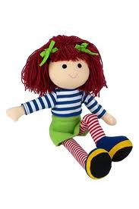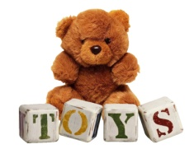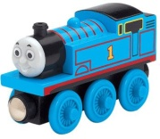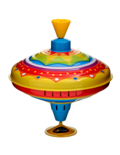[](http://images.google.co.uk/imgres?imgurl=http://oswalrishta.com/new/Pharmazone/images/laptop-icon.gif&imgrefurl=http://oswalrishta.com/new/Pharmazone/apply_now.php&usg=__F5NznrKVNb4_coYoqtv63dBK644=&h=78&w=72&sz=5&hl=en&start=4&itbs=1&tbnid=6cUDnSS0ywME7M:&tbnh=73&tbnw=67&prev=/images?q=laptop+icon&hl=en&gbv=2&tbs=isch:1)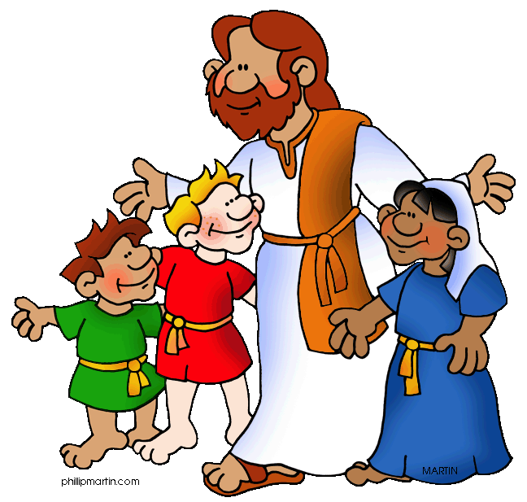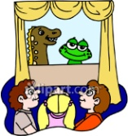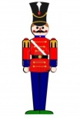

## **History**

* Ask and answer questions about the past:
* about toys and games from the past
* how to decide if toys are old or new
* how we can learn about the past in different ways

## **Mathematics**

* Time
* Number and Place value
* Mass/weight
* 2-D and 3-D Shape
* Counting and money
* Multiplication

## **Science**

* Plants – Seeds and BulbsMaterials – uses of everyday materials
* What are toys made out of?
* Investigate what is the best material for a bath time toy?
* Forces – Pushes and pulls
* Investigate how to make a toy car move furthest?

**Class 2 - Spring 1**

**What were toys like in the past?**

## **Music**

* Charanga – I want to play in a Band – Joanna Mangona

## **Computing**

* Finding information search engines on internet linking to history topic – Toys
* Staying safe online
* RM maths

## **PE**

* Indoor athletics
* Dance – exploring how different toys move

**PE is on Mondays and Wednesdays**, please make sure your child has a named PE kit in school on these days.

## **English**

* Story writing based on *Old Bear* by Jane Hissey
* Information text – Toys
* Phonics and Spelling
* Reading comprehension.

## **PSHCE**

* Dreams and Goals

## **RE**

* Jesus is a friend to everyone
* Discuss characters feelings, begin to empathise with characters

## **Art/Design Technology**

* Charcoal and pencil drawings of old/new teddy bears
* Design and make a puppet