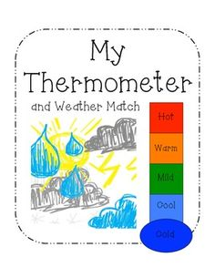C:\Users\Kelly\Pictures\Microsoft Clip Organizer\00117999.wmfC:\Users\Kelly\Pictures\Microsoft Clip Organizer\00232180.wmfC:\Users\Kelly\Pictures\Microsoft Clip Organizer\00022708.wmfC:\Users\Kelly\AppData\Local\Microsoft\Windows\Temporary Internet Files\Content.IE5\KMETZ76R\MC900235377[1].wmf 

Weather Vain

Rain Gauge

snowing

sunny

cloudy

raining

windy

stormy