China
Key Vocabulary |  | China is in Asia  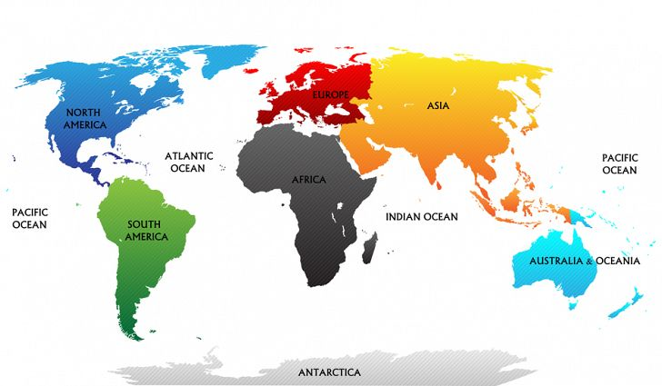 | Chinese Flag  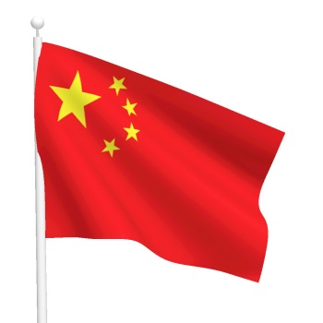
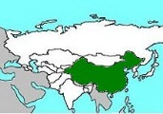 | Asia is the continent
 | China is the country
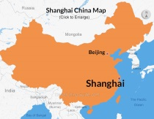 | Beijing is the capital city
 | Shanghai is the largest city
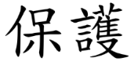 | The main language spoken in China is Mandarin |  | Chinese New Year is the biggest celebration of the year. It is in Spring and marks the end of the Winter.  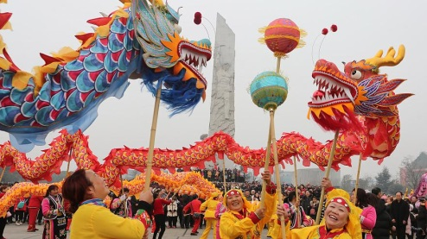
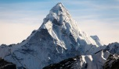 | Mount Everest is the highest mountain in the world. | 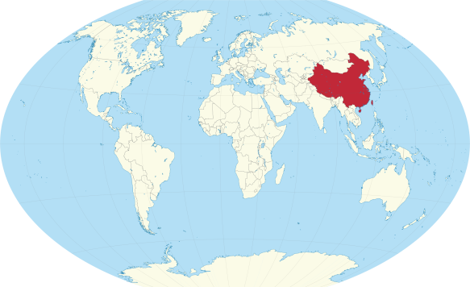
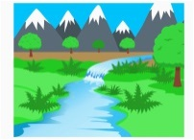 | The 2 main rivers in China are the Yellow River and the Yangtze River
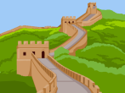 | The Great Wall of China is the longest structure ever built by humans | Map of China  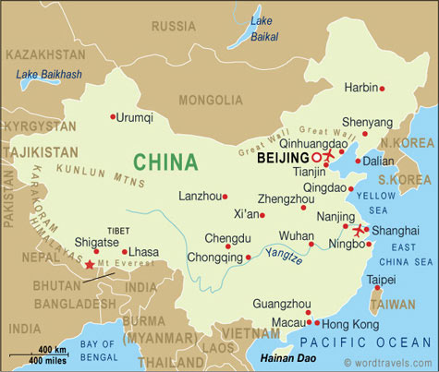 | China is the largest  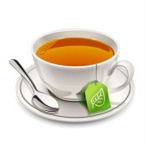  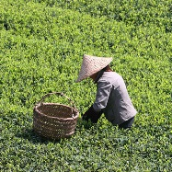  producer of tea in the world. | 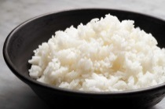  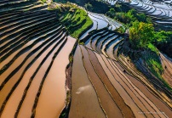  Rice is one of China’s biggest crops
 | China has a bigger population than any other country in the world – over 1.3 billion
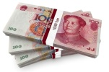 | The currency is the yuan

