A Warm Welcome to Foundation Stage

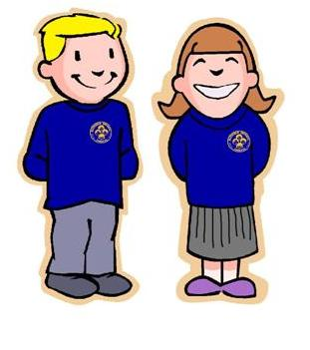
A few reminders:

- Please make sure all clothing is named. This includes coats, bags, uniform and PE kits.

- All children will need a named pair of wellington boots for outdoors.

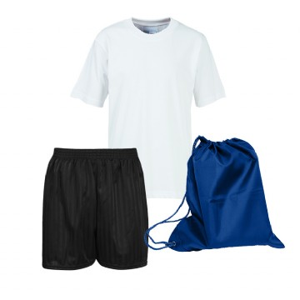
- PE kits can be sent into school and will be returned at each half term break to be washed and checked for size.

- If your child is absent, please ring the school office and let us know. If your child has a medical appointment, please take the letter to the school office and a copy will be taken.

- Reading books and the lending library will not start just yet and further information will follow shortly.

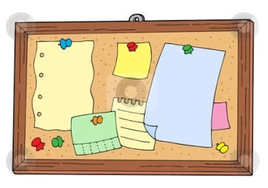
- Remember to keep an eye on Tapestry, St Johns school website, Facebook and the notice board for information and notices.

The Foundation Stage Team look forward to welcoming you and your child!

